ICS3CU Software Proposal Name _ __ Jeremy Dong _____

Program Name:
Sudoku

Explain how your game will work. Do not assume that I have played your game. Be sure to describe how all input will be received and all output will be displayed.
This is a one player game. A 9x9 grid will appear on the screen. The player selects one grid and enters a number for that grid. The objective is to fill the grid with digits so that each column, each row, and each of the nine 3×3 subgrids that compose the grid contains all of the digits from 1 to 9.

There’s a down count, the game is won when the player solves the problem within the given time, otherwise the player loses.

The player will be asked for name that appears on the leaderboard, and game difficulty.`

Screen Designs: Print this document and sketch key screens. (Introduction, main game, special cases, game over, etc)

Welcome to Sudoku  Play  Leaderboard  Exit |  | Game initialization  Please set your name: XXX  Please select your difficulty: 1-10  Start
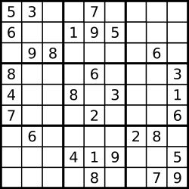  Name: XXX  Time used: xx:xx  Time left: xx:xx  Please input  your choice: X  (Please select a grid) |  | You WIN/LOSE  Your score: xx:xx(time used, if win)  Leaderboard  1 XXX xx:xx  2 XXX xx:xx  3 XXX xx:xx  …  X XXX xx:xx  (The player’s score if not in top-3)  Start Again  Exit

